19 November 2019

Dear Customer,
Thank you for your request for further information about NIBSC.
NIBSC is a centre of the Medicines and Healthcare Products Regulatory Agency, which is wholly owned by the UK government (Department of Health). Our role is to protect public health by helping to assure the quality of biological medicines. We distribute biological materials for laboratory use such as reference materials, research reagents and cell lines.
Sales terms and Conditions
Please note that NISBC as a UK Government Agency and centre of the WHO, is required to treat all customers equally and so we can only trade under our own terms and conditions which can be found on our website at http://www.nibsc.org/terms_and_conditions.aspx
As a not-for-profit UK government-funded scientific institute, we regret that we do not have the resources to undertake individual negotiations on our catalogue items. We do hope that you can understand our position and are able to accept our terms, including payment terms of 30 days from date of invoice, without amendment.
Frequently asked questions
How to place an order: https://www.nibsc.org/products/ordering/place_an_order.aspx
Product FAQs: https://www.nibsc.org/asset.ashx?assetid=de1eff26-ea17-466a-a001-1cc6fc991aad
Quality: http://www.nibsc.org/about_us/quality_and_governance.aspx
GDPR: https://www.gov.uk/government/publications/mhra-privacy-notice
Please note that if our products change, they are assigned a new product code and new Instructions for Use (IFU) are written with full details of the modified product. We do not issue Certificates of Analysis or Conformance as our IFU fulfills this function.
If you require further information or assistance, please contact us on standards@nibsc.org

Yours sincerely,

Alison James
Head of Standards Processing Division

Dear Customer,
The National Institute for Biological Standards and Control frequently receives enquiries/questionnaires from clients regarding how we conform to quality requirements for our products and services. Unfortunately, we are unable to complete individual supplier’s evaluation questionnaires however, we do have a number of accredited and certified Quality Management Systems (QMS) which are independently assessed as such by external Bodies to ensure compliance to all of the necessary requirements for each QMS. This letter describes briefly, the Institute’s Quality Systems.
NIBSC operates three formal Quality Systems, each of which demonstrates compliance to the appropriate Quality Standard.
ISO 9001:2015 –
NIBSC has a leading International role in preparing, evaluating and distributing International Biological Standards and other Biological Reference Materials. To ensure the continued high quality the products, these activities are independently certified to ISO 9001:2015 by The British Standards Institution (BSI). The scope of this certification includes amongst other activities, the Design, Formulation, Processing, Storage and Dispatch of filled and freeze dried Biological Materials. This Quality Management System is implemented to ensure the consistency of products which meets customer, and applicable regulatory requirements, and to enhance customer satisfaction through continual improvement.
ISO 13485:2016 –
The Institute manufactures in Vitro Diagnostic Devices (IVDs), which are processed in a quality environment conforming to requirements of ISO 13485:2016 and in compliance to the IVD Directive EU 98/79/EC. To ensure the continued high quality the products, these activities are independently certified to ISO 13485:2016 by UL International UK Ltd and CE-marked by Polskie Centrum Badań i Certyfikacji (PCBC) Polish Centre for Testing and Certification who are an EU Notified Body.
ISO 17025:2017 –
NIBSC provides independent testing of Biological Medicines for the UK market, in particular with vaccines for the UK children’s vaccination programme, and operates as an Official Medicines Control Laboratory (OMCL) of the European Union for release of medicines onto the EU market. This area of work is accredited by UKAS (UK Accreditation Service), and ensures competence and integrity of the organisation and reliability of the test data by compliance with internationally accepted criteria. The scope of this accreditation is available on request.
Please find copies of our current certificates for ISO 9001, EC Certificate and ISO 17025 at http://www.nibsc.org/about_us/quality_and_governance.aspx

Yours sincerely

Jennifer Sandle
Quality Manager

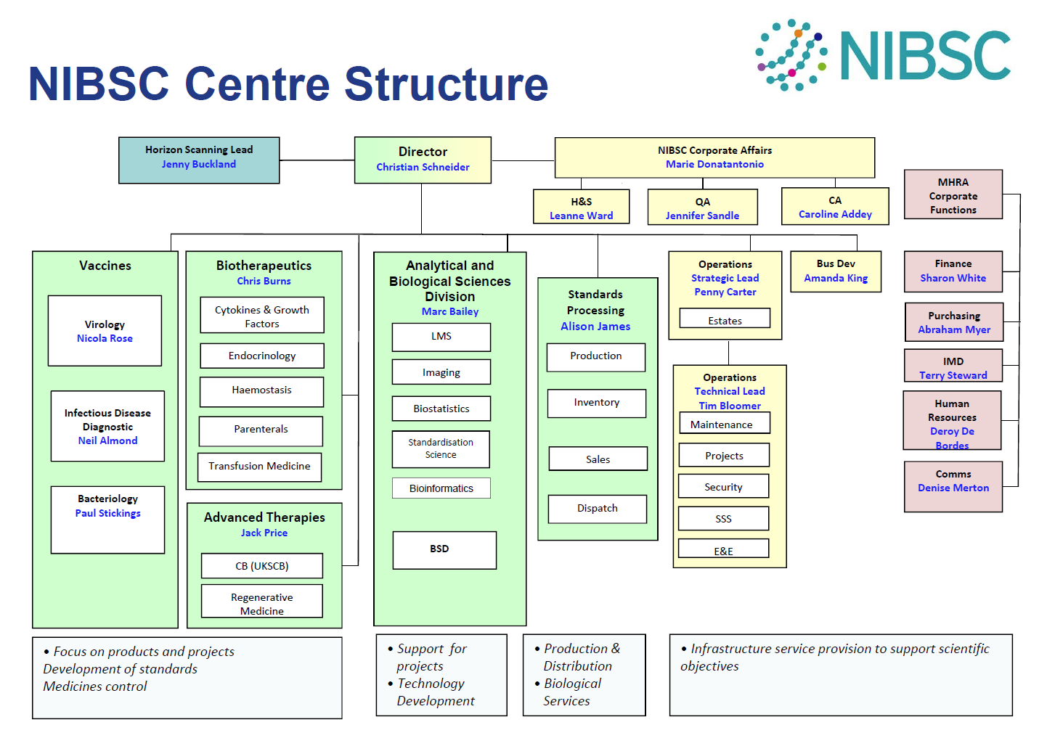

NIBSC INFORMATION FOR CUSTOMERS
All orders should be placed online: https://www.nibsc.org/products/ordering/place_an_order.aspx
If you experience problems ordering products, please contact us by emailing standards@nibsc.org
or telephoning +44 (0) 1707 64 1467

Company Name & Address | National Institute for Biological Standards and Control (NIBSC), Blanche Lane, South Mimms, Potters Bar, Hertfordshire, EN6 3QG, UK
Registered Name & Address | Medicines and Healthcare Products Regulatory Agency, 10 South Colonnade, Canary Wharf, London E14 9PU  Telephone (weekdays 9:00 -17:00): 020 3080 6000
 | Import Permits: materials are shipped from our company address which is different to our registered address.
Contact Person | Standards@nibsc.org
Phone Number (order queries) | +44 (0) 1707 64 1467
Fax Number | +44 (0) 1707 641064
Tax (VAT) No. | GB 888 8497 26
EORI | GB 888 8497 26 000
Registered In | United Kingdom
NIBSC Tax Id | NIBSC is part of the MHRA
NAICS Code | 541712
DUNS Number | 236678132
Site building area | 16,000 square metres
Quality staff | 5 plus departmental coordinators
Total Years in business | In business since 1972 and at present facility since 1987
No. employees | Approximately 350

Credit card payments | See Worldpay link on website www.nibsc.org
Telephone  (invoice queries) | +44 (0)20 3080 6533
E-mail queries | Sales.invoices@mhra.gov.uk
Invoice Number | SI 123456 - please quote this on payment remittance
Non credit card payments
Please note: unless you send an itemized remittance advice to the above address / email with:
- The name of your organisation AND
- The invoice numbers (SI 123456) AND
- The amounts you wish to pay
We will be unable to credit your account and you may be put on stop for future purchases.

Bank Name and Address National Westminster Bank PLC
280 Bishopsgate, London, EC2M 4RB. United Kingdom
Account Name MHRA
Account Number 10004386
Sort Code 60-70-80
Swift Code NWBKGB2L
IBAN Code GB68NWBK60708010004386
Terms of delivery DAP
Payment terms Payment within 30 days from the date on the Sales Invoice unless prepayment. Payment in GBP only.
Reminders Sent when an invoice becomes 21 days overdue;
a further reminder sent at 49 days

New account form http://www.nibsc.org/products/ordering/apply_for_an_account.aspx
We aim to ship orders within six working days of receipt unless there are queries to resolve. We will normally ship using DHL Express or DHL Global Freight but you may collect your shipments if you prefer. Our typical shipping charges can be found at https://nibsc.org/products/ordering/price_list.aspx

